Poker Algorithm Simulation
The goal of this project is to determine the ideal poker strategy by creating a bunch of different bots that play poker against each other and over time determining the best strategy. I created a neural network to determine the actions of each of the poker bots and bred the highest performing bots to create the next generation. Overtime the bots strategies converged and most of the winning bots from each generation employed a similar strategy.
The version of poker I programmed the bots to play was Texas Hold’em. In Texas Hold’em, each player is dealt two cards and a round of betting occurs called the pre-flop betting. Prior to the betting one player is assigned to be the small blind and the player to their left is assigned to be the big blind. The big blind is required to put in a minimum bet and the small blind is required to put in half of the minimum bet. Afterward the player to the left of the big blind can choose to either fold, check or raise. The betting continues until it comes back to the big blind if no one else has raised or if someone has raised until it comes back to them. Afterwards 3 cards are dealt face up on the table, these cards are called the flop, and another round of betting occurs. Players can combine the cards in their hand with the cards on the table to form their best 5 card hand. After the betting an additional single card, called the turn, is placed on the table followed by another round of betting. Finally the last card, called the river, is placed on the table followed by the last round of betting.
To create the poker bots this I used neural evolution, which involves creating a neural network where each of the weights between the nodes are completely randomized. Each generation I took the top 40% of the best performing bots to pass on to the next generation. In this 40%, the top 10% was moved to the next generation unchanged, the next 30% was moved to the next generation after some of the weights were randomly mutated. The remaining 60% of the next generation was created by combining the weight values of two of the bots in the top 40% of the previous generation. The neural network of each of the poker bots was constructed using 9 different input values. The number of chips the bot had, the strength of their hand, which stage of the game were they in (i.e preflop, flop, turn, or river), the size of the current betting pot, how many previous hands had been played, the number of other bots that had already folded, the number of bots that had raised this round of betting and the average number of chips the bots opponents had. These values were then passed into two hidden layers and the algorithm would output whether or not the bot should call/check, fold or raise as well as the amount the bot should raise by.
The reason to write this program is because poker is a very nuanced game with a wide variety of strategies and outcomes. Because of this it is challenging to determine what is the best poker strategy for long-term success. The program will help to identify the rates at which you should be betting, bluffing, how much you should be paying attention to your opponents and how much you should be managing your chips. In addition, because poker is a complex game with a variety of different outcomes, it can be challenging to directly write an algorithm to successfully play poker. By using genetic algorithms we can select the best poker strategy in order to create a bot that is a challenging opponent to play poker against. Finally many of the learnings from this project can be applied to other areas such as economics and business where people must make decisions based on limited data as well as the potential actions of their opponents. This project allows us to study different decision-making processes under conditions of uncertainty and risk.
The HandStrengthGenerator class is responsible for calculating and storing how strong different poker hands are, based on simulations. It does this ahead of time so that during actual gameplay, poker bots can look up the strength of their hand instantly rather than calculating it from scratch every time. The class carries out two major types of simulations: one for two-card starting hands before any community cards are dealt (pre-flop), and another for complete five-card hands representing each possible type of hand ranking, like a flush or full house.
To store all this information, the class uses a large dictionary-like structure called a map. In this map, each hand is represented by a unique label (like “PAIR | 9” for a pair of nines or a string showing two cards like “Card: Ac Card: Kc”), and the value associated with that label is a decimal number between 0 and 1. This number tells us how likely that hand is to win against a random opponent hand, based on thousands of simulated games.
When running pre-flop simulations, the class first generates every possible combination of two cards a player might be dealt. For each of these hands, it simulates thousands of games. In each game, it deals a random set of three community cards (the flop) and gives a random hand to the opponent. It then combines the player’s two cards with the community cards to form a full five-card hand and does the same for the opponent. It compares these hands to determine whether the player wins, loses, or ties, and it keeps track of these outcomes. After enough games have been played, it calculates the hand’s win rate and saves it in the map.
The second major simulation focuses on complete five-card hands, especially hands that fall into specific ranking categories like straights, full houses, or four-of-a-kinds. Rather than simulating every possible hand of each type—which would take far too long—it creates a representative sample of hands for each ranking. For example, it might simulate a flush made of low cards, another made of high cards, and so on. For each of these example hands, it runs thousands of games where it is matched up against a random five-card hand from the deck. Just like in the pre-flop simulation, it tracks wins and ties to compute a probability of success. These values are stored in the map using a key that includes the hand’s rank and, where relevant, important cards like the highest pair or the highest card in the hand.
The BotSelector class is the manages the evolutionary process in the poker bot simulation. Its main job is to run a genetic algorithm that creates, tests, and improves a large population of poker-playing bots over many generations. The goal is to evolve better-performing bots by mimicking the process of natural selection—allowing the strongest bots to survive, introducing random mutations, and combining traits from successful bots to form new ones.
For every generation, the BotSelector runs a large number of poker games. Each game is played using a subset of five randomly selected bots from the population. During these games, bots compete by playing poker rounds and making decisions using their neural networks. After enough games have been played to assess how each bot performs, the class ranks them based on their overall effectiveness—how many chips they won, how many hands they played and won, and how balanced their strategies were. Once all bots in a generation have been evaluated, the BotSelector selects the best performers and prepares the next generation.
The Card class represents a single playing card from a standard deck. Each card has two key properties: its rank (a number between 2 and 14, where 11 is Jack, 12 is Queen, 13 is King, and 14 is Ace) and its suit (a character representing clubs, diamonds, hearts, or spades). The class can compare itself to other cards, it can check if it’s equal to another card, and it can print itself in a human-readable format.
The Hand class represents a group of playing cards held by a player or shared on the table. It holds a list of Card objects and contains logic for building, modifying, and evaluating that hand. You can add one or more cards to a hand, copy another hand and merge one hand with another. The Hand class also stores the hands rank is by utilizing the Hand Evaluator class.
The Deck class creates a full 52-card deck used in poker by utilizing the Card class. It includes methods to shuffle the deck randomly, deal cards one by one, and provide access to the list of cards in the deck. Each time a card is dealt, it is removed from the deck, similarly to a real game.
The HandEvaluator class is responsible for determining the rank of a poker hand It works with directly with a Hand object, which holds the actual cards, to determine what rank that hand is. To categorize hands, the class follows the traditional poker hand rankings, from strongest to weakest: straight flush, four of a kind, full house, flush, straight, three of a kind, two pair, one pair, and high card. First the class checks for the strongest possible hands, like a straight flush or four of a kind, and works its way down. As soon as it identifies a valid ranking, it assigns that rank to the hand and stops looking further. For example, if a hand is both a straight and a flush, it will be marked as a straight flush, the stronger of the two.
The PokerBot class represents an AI-controlled poker player that participates in simulated games. Each bot has a “brain” in the form of a neural network and is designed to learn and improve over time using a genetic algorithm. Each bot starts a game with a certain number of chips and is dealt a hand of two private cards. As the game progresses and community cards are revealed, the bot must decide whether to fold, call, or raise based on the current game state by utilizing its neural network, which was created using a set of weights and biases stored in a BotGenetics object. The bot also uses precomputed hand strength values from the HandStrengthGenerator class that identify how likely a given hand is to win. The bot also keeps track of how often it folds, calls, or raises, how many hands it has won, and how many chips it has gained or lost over time. This information is used to calculate a fitness score, which helps determine how successful the bot is. The fitness score is based on a combination of win rate, chip gains, and behavior balance (penalizing bots that only ever fold or only ever raise). Bots with higher scores are more likely to be selected for survival or reproduction in the next generation
The BotGenetics class is the blueprint for a poker bot’s decision-making system. It stores all weights and biases that control the behavior of the bot’s neural network. These values are used to build the layers of the network that process inputs and decide whether to fold, call, or raise during a poker game. The class contains three main sets of weights: one for the first hidden layer of the neural network, one for the second hidden layer, and one for the output layer. In addition, it stores a set of bias values, which help adjust the output of each neuron in the network. All of these values are stored as multi-dimensional arrays or lists of numbers. The BotGenetics class also contains a mutation method which slightly alters some of the weights and biases based on a probability that depends on the generation number. In earlier generations, mutations are more frequent to encourage exploration and variety. As the simulation progresses, the mutation rate decreases, helping the population of bots converge toward more refined strategies.
The NeuralNetwork class is the brain of each poker bot. It is a simple, feedforward neural network that takes in game-related information and produces a decision about what action the bot should take: fold, call, or raise. The neural network is created using the weights and biases stored in the BotGenetics. The network consists of three layers: two hidden layers that process information and an output layer that determines the final action and raise amount. Once the inputs are received, they are passed through the first hidden layer, which consists of 16 nodes. Each node performs a calculation using the input values and the weights and biases stored in the bot’s genetics. The output of each node is then passed through an activation function, which is simply a rule that says negative values become zero. The results are then sent to the second hidden layer, which has 8 more nodes that repeat a similar process.
After processing through the two hidden layers, the output layer makes the final decision. It calculates scores for each possible action—fold, call, or raise—and uses a method called softmax to turn these scores into probabilities. The action with the highest probability is chosen. If the chosen action is to raise, the network also calculates how much the raise should be using a separate neuron dedicated to that task.
The GameEngineSimulator class runs the actual poker games between the bots. It handles dealing cards, betting rounds, determines the winners and progressing through multiple hands. At the start of each simulation, the class initializes a set of poker bots, giving them a defined number of chips and adding them to the game. Each round of the simulation begins by resetting the deck and preparing a new set of community cards. The engine assigns the small and big blinds, deals two hole cards to each bot, and rotates the dealer position to simulate the flow of a real poker game.
The game progresses through the stages—preflop, flop, turn, and river—in Texas Hold’em and at each stage, the engine runs a betting round where bots take turns deciding whether to fold, call, or raise. These decisions are handled by the neural network of the bots but the engine enforces the rules: it keeps track of how many times players have raised or called, adjusts the pot, and ensures that players meet the current call amount or fold if they choose not to. If only one bot remains after a betting round, it is immediately awarded the pot and the round ends early. If multiple bots continue through all stages, the engine determines the winner based on the best five-card hands formed using each bot’s hole cards and the community cards. If there’s a tie, the pot is split evenly among the winners. After each hand, the engine resets the game state. It removes bots that have run out of chips and prepares for the next round by clearing the pot and community cards. The process continues until either only one bot is left or a fixed number of rounds have been played. 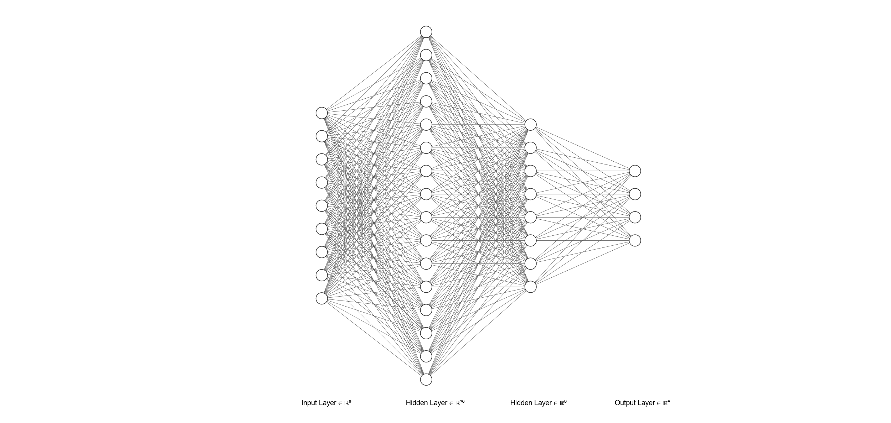
Figure 1 Diagram of Neural Network

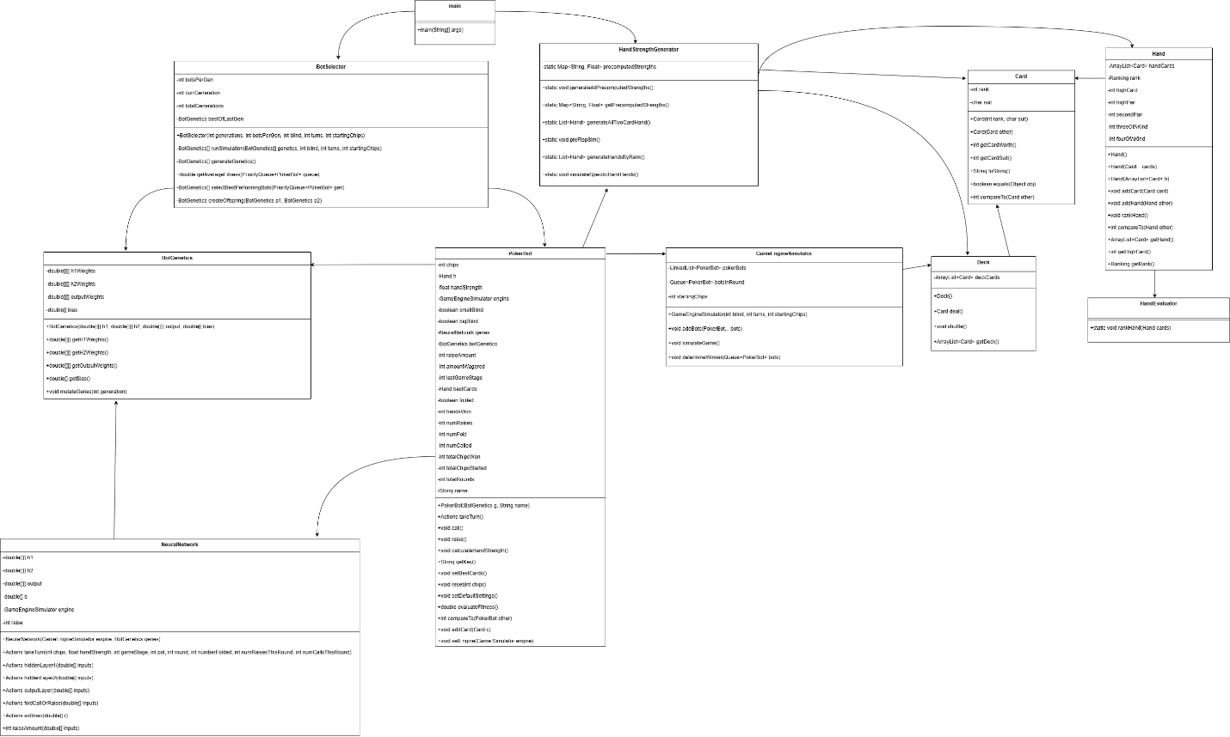
Figure 2 UML of PokerPoject

